Biological Oscillators
  - The coupling mechanism between glycolytic and mitochondrial membrane potential oscillators.

Introduction
A biological oscillator is a system that provides regular and repeating changes to biological activity over time. They are essential for biological function and regulate processes such as circadian rhythms, heartbeat, and metabolism. An interesting example, and the focus of this report, is the interaction between glycolytic and mitochondrial membrane-potential oscillators.
Mitochondria generate adenosine triphosphate (ATP) through oxidative phosphorylation, using a proton gradient across their inner membrane. Changes in ATP and adenosine diphosphate (ADP) concentrations influence glycolytic activity and mitochondrial respiration, providing a mechanism for these processes to interact. These two oscillating systems are coupled metabolic and electrical oscillations (Olsen et al., 2009). This essay aims to investigate the mechanisms behind these oscillations and examine the mathematical models the researchers used to describe them.
ATP synthesis is present in all studied organisms, which is what makes this topic so interesting - it is the basis that all life functions on!

Biological mechanisms and interactions
Glycolysis is a metabolic process where glucose is broken down into pyruvate. This also produces ATP and nicotinamide adenine dinucleotide (NADH) – a molecule whose autofluorescence allows it to be measured easily. Glycolytic enzymes exhibit oscillatory activity, which causes periodic changes in the concentrations of NADH.
At the inner membrane of the mitochondria, electrons from NADH provide enough energy to push protons from the matrix into the intermembrane space via the electron transport chain. This process creates an electrochemical gradient (the proton-motive force) and, hence, the protons want to diffuse back into the matrix. ATP synthase lies across the membrane and provides a pathway for protons to flow down the electrochemical gradient back into the matrix. This flow causes ATP synthase to spin like a turbine, and the energy is used to facilitate the phosphorylation of ADP into ATP.
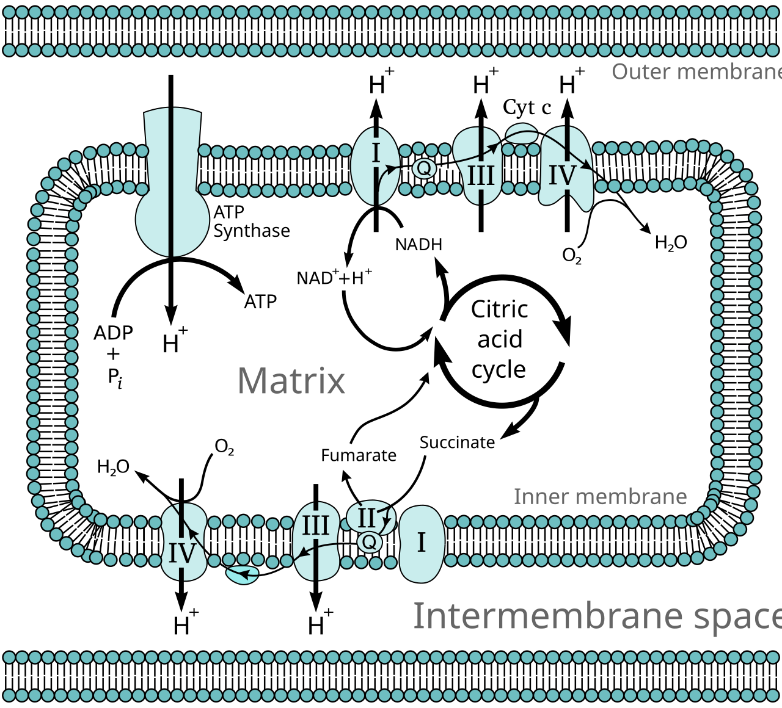
Figure 1 - Shows the electron transport chain in the mitochondria: the interaction of NADH with the inner mitochondrial membrane (proton pumping); the proton-motive force; and, ATP synthesis through ATP synthase. (‘Electron transport chain’, 2026)
Changes in the glycolytic activity influence the availability of ATP, while mitochondrial respiration and ATP production regulate the ATP/ADP balance. This creates a link between the two systems, allowing changes in one to influence the other.
Olsen et al. (2009) experimented with this interaction by simultaneously measuring glycolytic NADH oscillations and the mitochondrial potential ($Δψ_{m}$) in the yeast Saccharomyces cerevisiae and found that NADH and $Δψ_{m}$ oscillate in phase.

Mathematical models and findings
The interaction between glycolysis and mitochondrial respiration can be modelled using coupled ordinary differential equations (ODEs). These equations describe how the concentrations of NADH (alongside other metabolites) and $Δψ_{m}$ change over time.
Olsen and Lunding (2024) used a data-driven mathematical approach called Sparse Identification of Nonlinear Dynamics (SINDy) to convert experimentally measured time-dependent changes in NADH, intracellular ATP, $Δψ_{m}$, and intracellular potassium concentration into mathematical relationships between the variables.

The researchers produced the following system of equations (relabelled for easier discussion):
$$\frac{dN}{dt}=0.2329A-0.2195K-0.1981A^{2}+0.183K^{2} \left(1\right) \\ \frac{dA}{dt}=0.1497A-0.2895AK \left(2\right) \\ \frac{dΔψ_{m}}{dt}=0 \left(3\right) \\ \frac{dK}{dt}=-0.1109A-0.1341N^{2}+0.1379NΔψ_{m}+0.0955NK+0.2195A^{2}-0.1831Δψ_{m}K+0.0633K^{2} (4)$$
Here, $N$, $A$, and $K$ represent the rescaled concentrations of NADH, ATP, and intracellular potassium, respectively. The model attempts to describe the relationship between these variables.
The equations suggest that ATP and potassium influence NADH dynamics (Equation 1) and that ATP dynamics are affected by the concentration of potassium (Equation 2). They also show that potassium dynamics (Equation 4) are influenced by all three of the other variables. This suggests that potassium plays a vital role in coordinating the metabolic processes.
Although, there is an important limitation worth noting. The authors explain that Equation 3 predicts no change in the potential as it is likely the experimental data did not provide a sufficiently strong signal for SINDy to identify. Consequently, the model does not reproduce the exact behaviour of both oscillators.
Despite this, the study shows a link between the concentrations of NADH, ATP, and intracellular potassium. Demonstrating how mathematical models can be used to identify interactions between processes as small as glycolysis and mitochondrial respiration.
Other researchers have also investigated the relationship between the concentration of NADH and the mitochondrial membrane potential and have produced more detailed mathematical models. For example, Bertram et al. (2007) modelled glycolytic NADH, ADP, calcium, and mitochondrial membrane potential in pancreatic islets: their simulations demonstrated how glycolytic oscillations can produce changes in NADH, which influence membrane potential and ATP production. However, this provides a far more detailed representation of the interaction, by incorporating several additional variables and metabolites, making the coupling mechanism too complex to discuss in this report.

Discussion and evaluation
The experimental findings of Olsen et al. (2009) and the complementary mathematical models of Olsen and Lunding (2024) provide evidence of interactions between glycolytic and mitochondrial activity. The glycolytic oscillations were demonstrated to be associated with changes in the mitochondrial membrane potential, hence supporting the idea that these processes are coupled. Olsen and Lunding found that the relationships between the variables provided by SINDy identified interactions involving NADH, ATP, and intracellular potassium.
However, their mathematical model has limitations as it models no change in the membrane potential. This means that the model does not fully reproduce the oscillatory behaviour observed experimentally. It is important to note that this does not demonstrate that the potential has no effect on the system, instead it highlights that converting experimental results into biological models is challenging and requires further investigation, such as Bertram et al. (2007).

Conclusion
Glycolytic and mitochondrial membrane potential oscillations are important biological processes that interact to regulate cellular energy metabolism and hence are fundamental to supporting life. The coupling between the two oscillators involves exchanging and consuming ATP and ADP, as well as a changing mitochondrial membrane potential ($Δψ_{m}$). Experimental research by Olsen et al. (2009) shows coordinated, in-phase oscillations between NADH and $Δψ_{m}$, while the mathematical modelling by Olsen and Lunding (2024) identifies potential relationships between the concentrations of NADH, ATP, and intracellular potassium. However, further investigation would be required to establish the effect the mitochondrial membrane potential has on the system and whether it has a greater influence than potassium. This demonstrates the difficulty of translating between experimentally measured biological data into accurate models, suggesting a more complex model is needed to accurately reflect the behaviour of the processes (Bertram et al., 2007).

References
Bertram, R. et al. (2007) ‘Interaction of Glycolysis and Mitochondrial Respiration in Metabolic Oscillations of Pancreatic Islets’, Biophysical Journal, 92(5), pp. 1544–1555. Available at: https://doi.org/10.1529/biophysj.106.097154.
‘Electron transport chain’ (2026) Wikipedia. Available at: https://en.wikipedia.org/w/index.php?title=Electron_transport_chain&oldid=1383772866 (Accessed: 7 November 2026).
Olsen, L.F. et al. (2009) ‘Regulation of Glycolytic Oscillations by Mitochondrial and Plasma Membrane H+-ATPases’, Biophysical Journal, 96(9), pp. 3850–3861. Available at: https://doi.org/10.1016/j.bpj.2009.02.026.
Olsen, L.F. and Lunding, A. (2024) ‘On the coupling of intracellular K+ to glycolytic oscillations in yeast’, Yeast, 41(8), pp. 486–498. Available at: https://doi.org/10.1002/yea.3972.

